# Software Requirement and DesignSpecifications

**Fashion Store (E-commerce Website)**

|  |  |
| --- | --- |
| *Course Code* | CS-3004 |
| *Instructor* | Miss Nida Munawar |
| *ProjectTeam* | Noor Fatima (20K-0406)  Eisha Fatima (20K-0383)  Bismah Akram (20K-0449)  BSCS-5D |
| *SubmissionDate* | 6th December 2022 |

**TableofContents**

1. INTRODUCTION 5
   1. Purpose ofDocument 5
   2. Intended Audience 5
2. OVERALLSYSTEMDESCRIPTION 6
   1. ProjectBackground 6
   2. ProjectScope 6
   3. NotInScope 6
   4. ProjectObjectives 6
   5. Stakeholders 6
   6. Operating Environment 6
   7. SystemConstraints 6
   8. Assumptions&Dependencies 6
3. EXTERNALINTERFACEREQUIREMENTS 7
   1. HardwareInterfaces 7
   2. SoftwareInterfaces 7
   3. CommunicationsInterfaces 7
4. FUNCTIONALREQUIREMENTS 8
   1. FUNCTIONALHIERARCHY 8
   2. UseCases 8
      1. [Titleofusecase] 8
5. NON-FUNCTIONALREQUIREMENTS 9
   1. PerformanceRequirements 9
   2. SafetyRequirements 9
   3. SecurityRequirements 9
   4. UserDocumentation 9

SDS 10

1. SYSTEMARCHITECTURE 11
   1. SYSTEM LEVELARCHITECTURE 11
   2. SOFTWARE ARCHITECTURE 11
2. DESIGNSTRATEGY 12
3. DETAILEDSYSTEM DESIGN 13
   1. DATABASE DESIGN 13
4. APPLICATIONDESIGN 15
5. REFERENCES 15
6. APPENDICES 17

## Introduction

##### PurposeofDocument

To depict the process flow of our project, namely “Fashion Store” (E-commerce website).

##### Intended Audience

##### Intended audience will be customers who are interested in buying clothes from the fashion store. Especially young women are catered as we have clothes for women specifically.

* 1. **DefinitionofTerms,AcronymsandAbbreviations**

|  |  |
| --- | --- |
| **Term** | **Description** |
| ASP | ActiveServerPages |
| DD | DesignSpecification |
|  |  |
|  |  |
|  |  |
|  |  |
|  |  |
|  |  |

##### DocumentConvention

Font size for text: 12

Font size for headings: 14

Font type: Times Roman

## OverallSystemDescription

##### ProjectBackground

The purpose of our project is to create a fashion store for young women who are into unconventional styles when it comes to clothing, along with keeping mind comfort and originality, embracing their femininity. As nowadays more emphasis is put on mirroring other brands, however we wanted to create something unique.

We have also intended to create an interactive user interface, in which the user can select any product they wish to buy and place an order accordingly.

##### ProjectScope

In this project, we have created a simple and easy-to-understand user interface where users can view products from a range of products and then choose any product they like, either to add to Wishlist or cart. To place an order, they would have to register an account and login, and then proceed to payment details after which they will have successfully placed the order.

There is also an admin section for the administrator of the website who can add, update and delete products of their choice.

##### NotIn Scope

We have not added any section for employees of the store.

##### ProjectObjectives

We intend to create a store with more unique and unconventional clothing for women, as nowadays many brands fail to address the wishes of female customers. Our goal is to cater to their needs according to style and comfort zone both, hence why we created the website.

The end result would be a store where all women would be eager to purchase products according to their taste.

##### Stakeholders

1. Admin who has full authority of the website, and can add, update and delete any product.

2. User who can view products list, select any product and add it to wishlist or cart, and then proceed to purchase. They must also create an account in order to purchase.

3.Developer who has developed the project and awaits further releases.

4. Investors who may want to invest into the store in the future.

##### OperatingEnvironment

Any kind of PC or laptop will do, as long it can load a webserver. A web browser is needed. Any operating system is acceptable, including Windows and Linux.

##### SystemConstraints

[Describetheconstraints imposed onthesystembytheexternalenvironment.Externalenvironmentmaybe caused by the stakeholders, business conditions, technical issues, academic requirements etc andmayincludethefollowing:

* + - Softwareconstraints: Web browser is needed, along with operating system.
    - Hardwareconstraints: Laptop, PC or mobile phone needed to run the website.
    - Culturalconstraints: The user should know basic English.
    - Userconstraints: The website is targeted at women as there is clothing for women only, but any gender can access the website.

##### 

##### Assumptions&Dependencies

We have assumed that the user can access a basic operating system such as PC or laptop. The Operating System must also have a compatible Web browser to access and load the website.

Another assumption is that the user must be interested in buying clothes for women, as the store only has clothing for women and the target audience is women.

## FunctionalRequirements

##### FunctionalHierarchy

Admin will login to the system and if they want, they can add, update or delete products from the website.

#### User will register an account, login to it and view the products page. If they want to add product to wishlist, they can do so or remove product from wishlist. They can also add product to cart if they wish to buy, or remove product from cart. They can fill in payment details and place order. Also, they could place a review for the product or website.

#### List of functional requirements:

#### 1.Add product

#### 2.Delete product

#### 3.Update product

#### 4.Checkout

#### 5.Payment

#### 6.Add to cart

#### 7.Add to Wishlist

#### 8.Remove from cart

#### 9.Remove from Wishlist

#### 10.Add discount code

#### 11.Add comment review

#### 12.Add rating review

#### 13.Set shipping charges

#### 14.Calculate total amount

#### 15.Place order

#### 16.View order details

#### 17.View available products

#### 18.View product details

#### 19.Select product

#### 20.Update cart

#### 21.View cart

#### 22.View Wishlist

#### 4.2. Use Cases

##### 4.2.1.

|  |  |
| --- | --- |
| ID | UC-1 |
| Use case name | Register |
| Author | Noor Fatima |
| Last revision | 1/12/2022 |
| Description | The user registers itself on the website by providing the required information. |
| Primary Actor | User |
| Supporting Actor | None |
| Stakeholders: | Admin, user, database |
| Relationships  Includes:  Extends: | Credentials verified  Invalid credentials |
| Pre-conditions | The student must have a valid registered email address. |
| Post-conditions | Successfully logged in and redirected to the home page |
| Main success scenario | 1. User opens the website. 2. User goes to the account page 3. User selects the register section 4. User enters its first name and last name 5. User enters a username 6. User enters its email address 7. User enters a password and then enters it again for verification purposes 8. User enters its gender and date of birth 9. User clicks the register button. 10. User successfully registers itself to the system. 11. User is redirected to the home page |
| Extensions | *a. At any time, in case of an error, it can be dealt with at any step in the scenario  4. User enters numbers instead of a name and gets an error   * 4a. User enters correct inputs   6. User enters an email without the email extension and receives an error   * 6a. User enters correct email address   7. User enters different password the 2nd time   * 7a. User enters the password again   10. The credentials aren’t verified when logging in, and an error appears. |

|  |  |
| --- | --- |
| ID | UC-2 |
| Use case name | Login |
| Author | Noor Fatima |
| Last revision | 1/12/2022 |
| Description | The user logins into the website by using its login credentials. |
| Primary Actor | User |
| Supporting Actor | None |
| Stakeholders: | Admin, user, database |
| Relationships  Includes:  Extends: | Credentials verified  Invalid username or password |
| Pre-conditions | The student must have registered itself on the website |
| Post-conditions | Successfully logged in and redirected to the home page |
| Main success scenario | 1. User opens the website. 2. User goes to the account page 3. User selects the login section 4. User enters its correct username and password 5. User clicks the login button 6. User successfully logs into the website 7. User is redirected to the home page |
| Extensions | *a. At any time, in case of an error, it can be dealt with at any step in the scenario  4. The credentials aren’t verified when logging in, and an error appears. |

|  |  |
| --- | --- |
| ID: | UC-3 |
| Use case name: | View Product page |
| Author: | Eisha Fatima |
| Last revision: | 5/12/2022 |
| Description: | User clicks on the product page, and then the whole list of products is displayed on the webpage. |
| Primary Actor: | User |
| Supporting Actor: | Database |
| Stakeholders: | User, Database |
| Relationships  Includes:  Extends: | None |
| Preconditions: | Home page is accessible to user. |
| Postconditions: | Products are displayed for user. |
| Main  Success Scenario: | 1. Student selects “Products” from the navigation bar. 2. Products are accessed from database. 3. Products of “Fashion Store” are loaded and displayed on the webpage for user to see. |
| Extensions: | *a. Website crashes while the user is viewing the home page.  1. User restarts the website, logs in, and requests recovery of prior state.  1a. No products are available right now for the user to view.  2a. Database is not able to load the products, due to error or because no products are available in the database. --- 2a1. User is asked to wait till products are restocked, and then try again. |

|  |  |
| --- | --- |
| ID: | UC-4 |
| Use case name: | Select Product |
| Author: | Eisha Fatima |
| Last revision: | 5/12/2022 |
| Description: | User selects a product from the list of products, and the product detail is displayed on the webpage. |
| Primary Actor: | User |
| Supporting Actor: | Database |
| Stakeholders: | User, database |
| Relationships  Includes:  Extends: | View Product detail |
| Preconditions: | Product page can be accessed to user. |
| Postconditions: | Product is successfully selected by user. |
| Main  Success Scenario: | 1. On the “Products” page, user clicks on any product they wish to buy.   2. Product details of the specific product are loaded from the database and displayed on the webpage.  3. User is able to see the product details i.e., name, size, price, quantity, total. |
| Extensions: | 1a. Website crashes.  --- 1a1. Error message displayed and user reloads the website.  2a. Database is not able to fetch the product details. |

|  |  |
| --- | --- |
| ID: | UC-5 |
| Use case name: | Choose Product details |
| Author: | Eisha Fatima |
| Last revision: | 5/12/2022 |
| Description: | User types in the product details they require for a particular product. Total price for the product is displayed. |
| Primary Actor: | User |
| Supporting Actor: | Database |
| Stakeholders: | User, database |
| Relationships  Includes:  Extends: | None |
| Preconditions: | User has already selected a product. |
| Postconditions: | Total price for the product is displayed. |
| Main  Success Scenario: | 1. User types in product details i.e., quantity of the product they wish to buy. 2. Total price of the product(s) is calculated by multiplying quantity with price. |
| Extensions: | 1a. Product is out of stock.  ---1a. User is alerted that the product is out of stock, and to choose another product.  2a. Error while calculating price, or price is not displayed. --- 2a1. User refreshes the page. |

|  |  |
| --- | --- |
| ID: | UC-6 |
| Use case name: | Add to Wishlist |
| Author: | Eisha Fatima |
| Last revision: | 5/12/2022 |
| Description: | User adds a product to the Wishlist, if they want to buy it later and not right now. |
| Primary Actor: | User |
| Supporting Actor: | Database |
| Stakeholders: | User, database |
| Relationships  Includes:  Extends: | None |
| Preconditions: | Product page and Wishlist page are accessible to user. |
| Postconditions: | Product(s) are added to wishlist. |
| Main  Success Scenario: | 1. User clicks on ‘Add to Wishlist’ button under product details page, of a product.  2. Database adds the product to Wishlist.  3. User opens Wishlist page from navigation bar.  4. All products in Wishlist are displayed. |
| Extensions: | 2a. Database is not able to add the product in Wishlist.  3a. Wishlist is empty, either because the product was not successfully added or there have been no products added to Wishlist yet.  ---3a. User goes back to product page and adds product to Wishlist. |

|  |  |
| --- | --- |
| ID: | UC-7 |
| Use case name: | Remove from Wishlist |
| Author: | Eisha Fatima |
| Last revision: | 5/12/2022 |
| Description: | User removes product from Wishlist if they no longer want to buy. |
| Primary Actor: | User |
| Supporting Actor: | Database |
| Stakeholders: | User, database |
| Relationships  Includes:  Extends: | None |
| Preconditions: | Wishlist page is accessible to user. |
| Postconditions: | Product is successfully removed from Wishlist. |
| Main  Success Scenario: | 1. User opens the Wishlist page. 2. User clicks on the ‘cross’ button to remove a product from Wishlist.  3. Product is successfully removed from Wishlist through database and is no longer seen on Wishlist page. |
| Extensions: | 3a. Product can still be seen on the Wishlist page, due to error.  ---3a. User either refreshes the page or clicks on the cross button again. |

|  |  |
| --- | --- |
| ID: | UC-8 |
| Use case name: | Add Product |
| Author: | Noor Fatima |
| Last revision: | 5/12/2022 |
| Description: | Admin adds a new product to the fashion store for customers to see. |
| Primary Actor: | Admin |
| Supporting Actor: | Database |
| Stakeholders: | Admin, user, database |
| Relationships  Includes:  Extends: | None |
| Preconditions: | Add product page is accessible to admin, and they are successfully logged in to their account. |
| Postconditions: | Product is successfully added in database and webpage. |
| Main  Success Scenario: | 1. Admin clicks on the Add product page.   2. Admin inputs product details of the product i.e., name, price, quantity, size and uploads image. 3. Product is added to database.   1. Product can now be displayed on the Products page for the user to see. |
| Extensions: | *a. Admin is unable to log in to their account i.e., root user.  1. Admin recovers their account and successfully logs in.  1a. Add product page is not successfully accessed.  2a. Invalid product details are input by the admin. --- 2a1. Admin is asked to input product details again.  4a. Product is not successfully added to database and hence not displayed on webpage.  ---4a1. Admin enters product details and adds product again. |

|  |  |
| --- | --- |
| ID: | UC-9 |
| Use case name: | Update Product |
| Author: | Noor Fatima |
| Last revision: | 5/12/2022 |
| Description: | Admin updates product details of a specific product(s). |
| Primary Actor: | Admin |
| Supporting Actor: | Database |
| Stakeholders: | Admin, User, database |
| Relationships  Includes:  Extends: | None |
| Preconditions: | Add Product page is accessible to admin, and admin is successfully logged in to their account. |
| Postconditions: | Product is successfully updated in database and on webpage. |
| Main  Success Scenario: | 1. Admin opens the Add Product page.   2. Admin enters the name of the product to update, and then the details to be updated. 3. Product is updated in the database.  4. New product details are displayed on webpage for user. |
| Extensions: | 2a. The product to be updated does not exist in the database.  ---2a1. Admin adds the product first, then updates it.  4a. Product details are still the same as previous ones. --- 4a1. Admin updates the product again. |

|  |  |
| --- | --- |
| ID: | UC-10 |
| Use case name: | Delete Product |
| Author: | Noor Fatima |
| Last revision: | 5/12/2022 |
| Description: | Admin deletes a product that they no longer want in the fashion store. |
| Primary Actor: | User |
| Supporting Actor: | Database |
| Stakeholders: | Admin, user, database |
| Relationships  Includes:  Extends: | None |
| Preconditions: | Delete product page is accessible to admin, and they are already logged in to their account. |
| Postconditions: | Product is successfully deleted from database and webpage. |
| Main  Success Scenario: | 1. Admin clicks on the Delete Product page.   2. Admin enters the name of the product to be deleted.  3. Product is deleted from database.  4. User can no longer see the deleted product on webpage. |
| Extensions: | 2a. Product to be deleted is not in database.  4a. The product that was deleted, can still be seen on webpage.  ---4a. Admin deletes product again. |

|  |  |
| --- | --- |
| ID: | UC-11 |
| Use case name: | View Cart page |
| Author: | Bismah Akram |
| Last revision: | 5/12/2022 |
| Description: | User clicks on the cart page, and then the whole list of products added to cart is displayed on the webpage. |
| Primary Actor: | User |
| Supporting Actor: | Database |
| Stakeholders: | User, Database |
| Relationships  Includes:  Extends: | None |
| Preconditions: | Home page is accessible to user. |
| Post conditions: | Products added to cart are displayed for user. |
| Main  Success Scenario: | 1. Student selects “Cart” from the navigation bar. 2. Products added to the cart from product page are displayed on the page |
| Extensions: | *a. Website crashes while the user is viewing the home page.  1. User restarts the website, logs in, and requests recovery of prior state.  1a. No products are available in the cart right now for the user to view.  2a. No products are available in the database. --- 2a1. User is asked to wait till products are added and then try again. |

|  |  |
| --- | --- |
| ID: | UC-12 |
| Use case name: | Add to Cart |
| Author: | Bismah Akram |
| Last revision: | 5/12/2022 |
| Description: | User adds a product to the cart if they want to buy it. |
| Primary Actor: | User |
| Supporting Actor: | Database |
| Stakeholders: | User, database |
| Relationships  Includes:  Extends: | None |
| Preconditions: | Product page and Cart page are accessible to user. |
| Post conditions: | Product(s) are added to the cart. |
| Main  Success Scenario: | 1. User clicks on ‘Add to Cart’ button under product details page, of a product.  2. Database adds the product to Cart.  3. User opens Cart page from navigation bar.  4. All products and product details in the cart are displayed. |
| Extensions: | 2a. Database is not able to add the product in Cart.  3a. Cart is empty, either because the product was not successfully added or there have been no products added to Cart yet.  ---3a. User goes back to product page and adds product to Cart. |

|  |  |
| --- | --- |
| ID: | UC-13 |
| Use case name: | Remove from Cart |
| Author: | Bismah Akram |
| Last revision: | 5/12/2022 |
| Description: | User removes product from Cart if they no longer want to buy. |
| Primary Actor: | User |
| Supporting Actor: | Database |
| Stakeholders: | User, database |
| Relationships  Includes:  Extends: | None |
| Preconditions: | Cart page is accessible to user. |
| Postconditions: | Product is successfully removed fromCart. |
| Main  Success Scenario: | 1. User opens the Cart page. 2. User clicks on the ‘cross’ button to remove a product from Cart.  3. Product is successfully removed from Cart through database, and is no longer seen on Cart page. |
| Extensions: | 3a. Product can still be seen on the Cart page, due to error.  ---3a. User either refreshes the page, or clicks on the cross button again. |

|  |  |
| --- | --- |
| ID: | UC-14 |
| Use case name: | Place Order |
| Author: | Bismah Akram |
| Last revision: | 5/12/2022 |
| Description: | User places order of the products they wish to buy. |
| Primary Actor: | User |
| Supporting Actor: | Database |
| Stakeholders: | User, database |
| Relationships  Includes:  Extends: | None |
| Preconditions: | Order details are accessible to User. |
| Post conditions: | Order is successfully placed. |
| Main  Success Scenario: | 1. User opens the “View Order Details” page. 2. User proceeds to payment and successfully pays the amount of their bill. 3. User clicks on ”Place Order” button 4. Order is successfully placed. |
| Extensions: | 2a. There is an error while writing the correct code  ---2a. User refreshes the page, and writes the code again. |

|  |  |
| --- | --- |
| ID: | UC-15 |
| Use case name: | View Order Details |
| Author: | Bismah Akram |
| Last revision: | 5/12/2022 |
| Description: | User clicks on the view order details and all the details of the project |
| Primary Actor: | User |
| Supporting Actor: | Database |
| Stakeholders: | User, Database |
| Relationships  Includes:  Extends: | None |
| Preconditions: | Order details are present. |
| Postconditions: | Order details are displayed for user. |
| Main  Success Scenario: | 1. Student selects “View Order Details” 2. Products and order details are displayed for User. |
| Extensions: | *a. Website crashes while the user is viewing the order details.  1. User restarts the website, logs in, and requests recovery of prior state. |

|  |  |
| --- | --- |
| ID: | UC-16 |
| Use case name: | Choose Payment Method |
| Author: | Bismah Akram |
| Last revision: | 5/12/2022 |
| Description: | User chooses the payment method and payment methods are displayed. |
| Primary Actor: | User |
| Supporting Actor: | Database |
| Stakeholders: | User, database |
| Preconditions: | Payment options must be given |
| Postconditions: | Correct payment method is choosen |
| Main  Success Scenario: | 1. User clicks on either cod or credit card button 2. User enters the credit card details if credit card is chosen by the user. 3. User pays the correct amount 4. Order is confirmed |
| Extensions: | 2. User enters wrong card details |

|  |  |
| --- | --- |
| ID: | UC-17 |
| Use case name: | Add review |
| Author: | Eisha Fatima |
| Last revision: | 5/12/2022 |
| Description: | User adds feedback in the form of comment and review. |
| Primary Actor: | User |
| Supporting Actor: | Database |
| Stakeholders: | User, database |
| Preconditions: | User must be registered with an account. |
| Postconditions: | Review is submitted. |
| Main  Success Scenario: | 1. User clicks on Review page. 2. User enters comment in the form of text. 3. User enters rating in the form of integer ranging from 1-5. 4. User submits review and it is stored in the database. |
| Extensions: | ---4a. Review is not submitted properly. |

## Non-functional Requirements

##### Performance Requirements

The software is reliable according to http and web browser protocols, as it uses a web server. Our project has been built to be responsive and reliable according to user expectations, along with storage friendly. Any bugs have been resolved accordingly.

##### Safety Requirements

No harm caused since this is a website on a web server. Safety certifications are according to http and web browser protocols.

##### Security Requirements

All data entered by user, such as account registration/login and credit card details, are protected according to data integrity as information of user is encrypted. Review feedback will remain anonymous to protect the privacy of users.

##### User Documentation

Website is easy to follow due to basic user interface.

# 

# SDS

## SystemArchitecture

In this project, there are two actors who will be accessing the system: admin and user. Admin will login to the system and if they want, they can add, update or delete products from the website.

User will register an account, login to it and view the products page. If they want to add product to wishlist, they can do so or remove product from wishlist. They can also add product to cart if they wish to buy, or remove product from cart. They can fill in payment details and place order. Also, they could place a review for the product or website.

### SystemLevelArchitecture

### SoftwareArchitecture

## DesignStrategy

Future system enhancement: We could include a section for employees where they could also access the page and see customer order details, for a better customer experience. We could also include an order tracking page so customers can see where their order currently is.

System reuse: Users from everywhere around the globe can access the website.

Concurrency and synchronization: At a time, either admin or user can access the page on one system as we have separated their sections. This ensures that all data is synchronized.

User interface paradigms: We have added a basic user interface with boxes, buttons and colors accordingly so it is easy for users to figure out what to do in the website. There are also multiple prompts in the form of boxes for user to input data such as user details and product details.

Data management: All data is stored in the fashion store database we have created, so there is a proper record kept of order details, product details and user details.

## DetailedSystemDesign

* Class diagram:

### 

### ECB diagram:

### 

**8.1. Database Design**

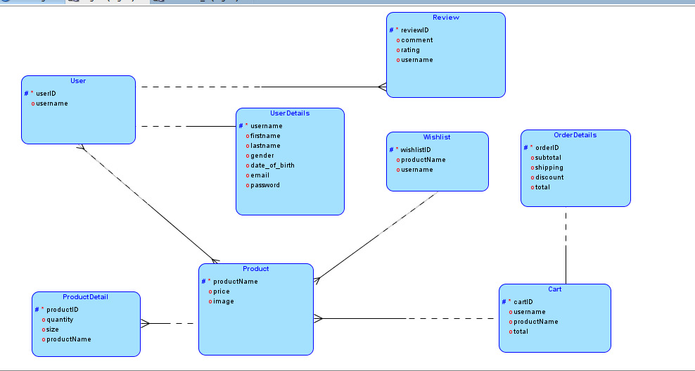

#### ERDiagram

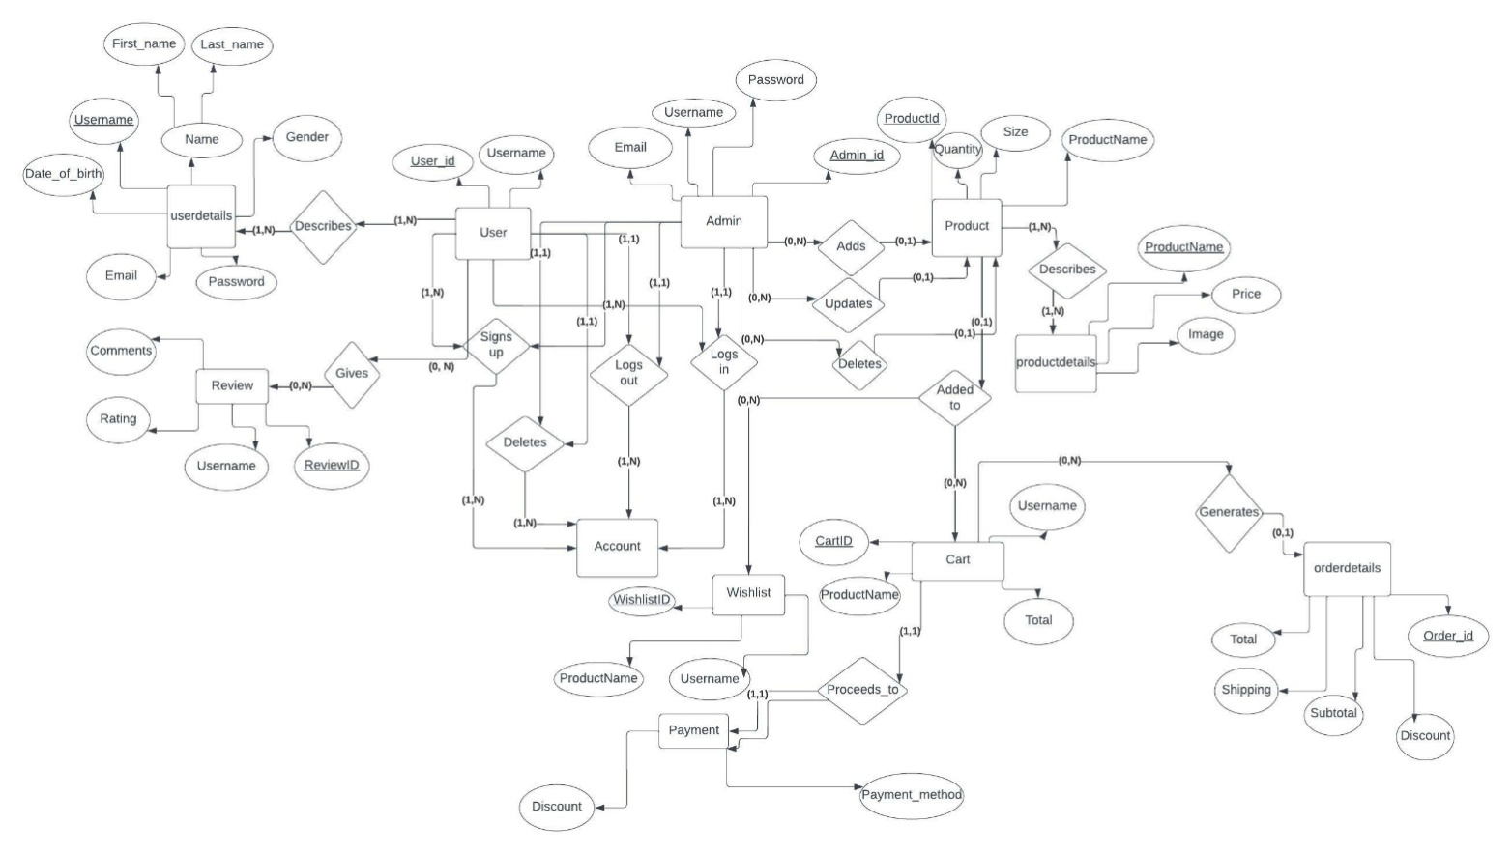

#### DataDictionary

|  |  |
| --- | --- |
| **<Data1>** | |
| ***Name*** | cart |
| ***Alias*** | Shopping cart |
| ***Where-used/how-used*** | Addtocart  Removefromcart  Proceed to payment |
| ***Contentdescription*** |  |

|  |  |
| --- | --- |
| **<Data2>** | |
| **Name** | orderdetails |
| **Alias** |  |
| **Where-used/how-used** | ViewOrderdetails  Placeorder |
| **Contentdescription** |  |

|  |  |
| --- | --- |
| **<Data3>** | |
| **Name** | productdetails |
| **Alias** |  |
| **Where-used/how-used** | Viewproductpage  Chooseproducts  Viewproductdetails |
| **Contentdescription** |  |

|  |  |
| --- | --- |
| **<Data4>** | |
| **Name** | products |
| **Alias** | items |
| **Where-used/how-used** | viewproductpage  addproduct  deleteproduct |
| **Contentdescription** |  |

|  |  |
| --- | --- |
| **<Data5>** | |
| **Name** | review |
| **Alias** | feedback |
| **Where-used/how-used** | Addrating  Addcomment  submitreview |
| **Contentdescription** |  |

|  |  |
| --- | --- |
| **<Data6>** | |
| **Name** | user |
| **Alias** | customer |
| **Where-used/how-used** | registeraccount  loginToAccount  viewWebsite  placeorder |
| **Contentdescription** |  |

|  |  |
| --- | --- |
| **<Data7>** | |
| **Name** | userdetails |
| **Alias** |  |
| **Where-used/how-used** | registeraccount |
| **Contentdescription** |  |

|  |  |
| --- | --- |
| **<Data8>** | |
| **Name** | wishlist |
| **Alias** | favorites |
| **Where-used/how-used** | Addtowishlist  removefromwishlist |
| **Contentdescription** |  |

**fashionstore**

# cart

|  |  |  |  |  |
| --- | --- | --- | --- | --- |
| **Column** | **Type** | **Null** | **Default** | **Comments** |
| CartID*(Primary)* | int(11) | No |  |  |
| ProductName | varchar(50) | No |  |  |
| Username | varchar(50) | No |  |  |
| Total | int(11) | No |  |  |

**Indexes**

|  |  |  |  |  |  |  |  |  |
| --- | --- | --- | --- | --- | --- | --- | --- | --- |
| **Keyname** | **Type** | **Unique** | **Packed** | **Column** | **Cardinality** | **Collation** | **Null** | **Comment** |
| PRIMARY | BTREE | Yes | No | CartID | 6 | A | No |  |
| Username | BTREE | No | No | Username | 6 | A | No |  |
| ProductName | BTREE | No | No | ProductName | 6 | A | No |  |

# orderdetails

|  |  |  |  |  |
| --- | --- | --- | --- | --- |
| **Column** | **Type** | **Null** | **Default** | **Comments** |
| order_id*(Primary)* | int(11) | No |  |  |
| Subtotal | int(11) | No |  |  |
| Discount | int(11) | No |  |  |
| Shipping | int(11) | No |  |  |
| Total | int(11) | No |  |  |

**Indexes**

|  |  |  |  |  |  |  |  |  |
| --- | --- | --- | --- | --- | --- | --- | --- | --- |
| **Keyname** | **Type** | **Unique** | **Packed** | **Column** | **Cardinality** | **Collation** | **Null** | **Comment** |
| PRIMARY | BTREE | Yes | No | order_id | 6 | A | No |  |

# productdetails

**Column**

**Type**

**Null**

**Default**

**Comments**

|  |  |  |  |  |
| --- | --- | --- | --- | --- |
| **Column** | **Type** | **Null** | **Default** | **Comments** |
| ProductName*(Primary)* | varchar(50) | No |  |  |
| Price | int(11) | No |  |  |
| Image | varchar(225) | No |  |  |

**Indexes**

|  |  |  |  |  |  |  |  |  |
| --- | --- | --- | --- | --- | --- | --- | --- | --- |
| **Keyname Type Unique Packed Column Cardinality Collation Null Comment** | | | | | | | | |
| PRIMARY | BTREE | Yes | No | ProductName | 8 | A | No |  |

# products

|  |  |  |  |  |
| --- | --- | --- | --- | --- |
| **Column** | **Type** | **Null** | **Default** | **Comments** |
| ProductId*(Primary)* | int(11) | No |  |  |
| ProductName | varchar(50) | No |  |  |
| Size | varchar(50) | No |  |  |
| Quantity | int(50) | No |  |  |

**Indexes**

|  |  |  |  |  |  |  |  |  |
| --- | --- | --- | --- | --- | --- | --- | --- | --- |
| **Keyname** | **Type** | **Unique** | **Packed** | **Column** | **Cardinality** | **Collation** | **Null** | **Comment** |
| PRIMARY | BTREE | Yes | No | ProductId | 8 | A | No |  |
| ProductName | BTREE | No | No | ProductName | 8 | A | No |  |

# review

|  |  |  |  |  |
| --- | --- | --- | --- | --- |
| **Column** | **Type** | **Null** | **Default** | **Comments** |
| review_id*(Primary)* | int(11) | No |  |  |
| Username | varchar(50) | No |  |  |
| Comment | varchar(255) | No |  |  |
| Rating | int(5) | No |  |  |

**Indexes**

|  |  |  |  |  |  |  |  |  |
| --- | --- | --- | --- | --- | --- | --- | --- | --- |
| **Keyname** | **Type** | **Unique** | **Packed** | **Column** | **Cardinality** | **Collation** | **Null** | **Comment** |
| PRIMARY | BTREE | Yes | No | review_id | 3 | A | No |  |
| Username | BTREE | No | No | Username | 3 | A | No |  |

# user

|  |  |  |  |  |
| --- | --- | --- | --- | --- |
| **Column** | **Type** | **Null** | **Default** | **Comments** |
| User_id*(Primary)* | int(11) | No |  |  |
| Username | varchar(50) | No |  |  |

**Indexes**

|  |  |  |  |  |  |  |  |  |
| --- | --- | --- | --- | --- | --- | --- | --- | --- |
| **Keyname** | **Type** | **Unique** | **Packed** | **Column** | **Cardinality** | **Collation** | **Null** | **Comment** |
| PRIMARY | BTREE | Yes | No | User_id | 7 | A | No |  |
| Username | BTREE | Yes | No | Username | 7 | A | No |  |

# userdetails

|  |  |  |  |  |
| --- | --- | --- | --- | --- |
| **Column** | **Type** | **Null** | **Default** | **Comments** |
| First_name | varchar(50) | No |  |  |
| Last_name | varchar(50) | No |  |  |
| Username*(Primary)* | varchar(50) | No |  |  |
| Email | varchar(50) | No |  |  |
| Password | varchar(225) | No |  |  |
| Gender | varchar(10) | Yes | *NULL* |  |
| Date_of_birth | varchar(50) | Yes | *NULL* |  |

**Indexes**

|  |  |  |  |  |  |  |  |  |
| --- | --- | --- | --- | --- | --- | --- | --- | --- |
| **Keyname** | **Type** | **Unique** | **Packed** | **Column** | **Cardinality** | **Collation** | **Null** | **Comment** |
| PRIMARY | BTREE | Yes | No | Username | 7 | A | No |  |
| Email | BTREE | Yes | No | Email | 7 | A | No |  |

# wishlist

|  |  |  |  |  |
| --- | --- | --- | --- | --- |
| **Column** | **Type** | **Null** | **Default** | **Comments** |
| WishlistID *(Primary)* | int(11) | No |  |  |
| ProductName | varchar(50) | No |  |  |
| Username | varchar(50) | No |  |  |

**Indexes**

|  |  |  |  |  |  |  |  |  |
| --- | --- | --- | --- | --- | --- | --- | --- | --- |
| **Keyname** | **Type** | **Unique** | **Packed** | **Column** | **Cardinality** | **Collation** | **Null** | **Comment** |
| PRIMARY | BTREE | Yes | No | WishlistID | 3 | A | No |  |
| Username | BTREE | No | No | Username | 3 | A | No |  |
| ProductName | BTREE | No | No | ProductName | 3 | A | No |  |

### ApplicationDesign

#### SequenceDiagram

#### User:

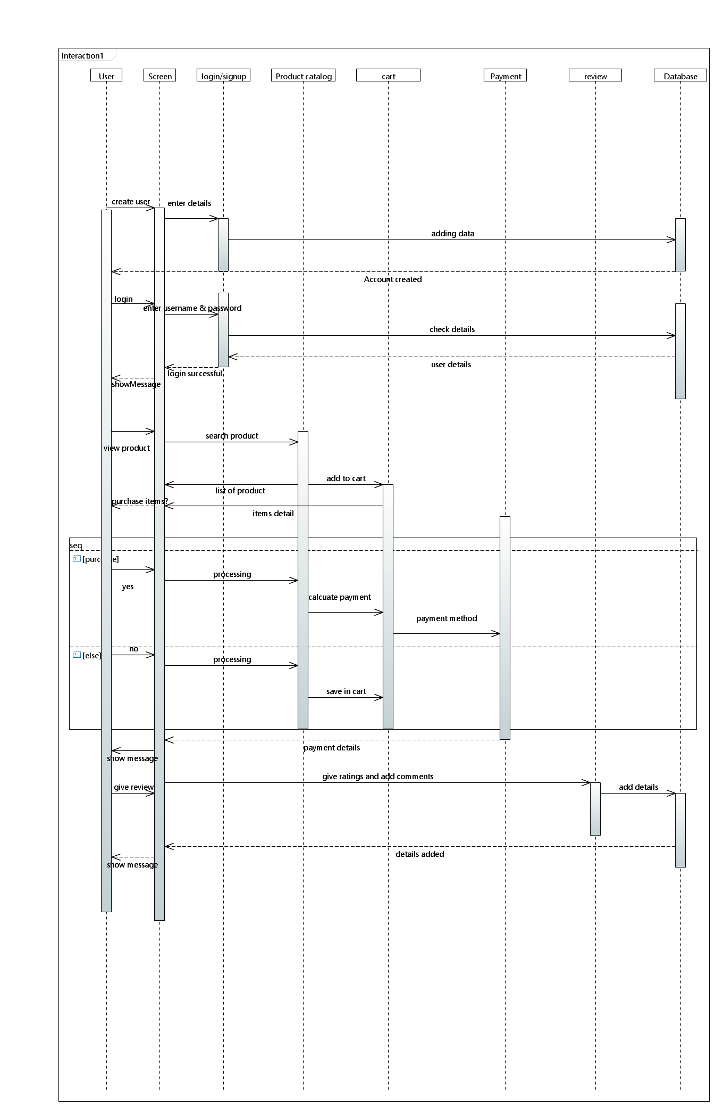

Admin:

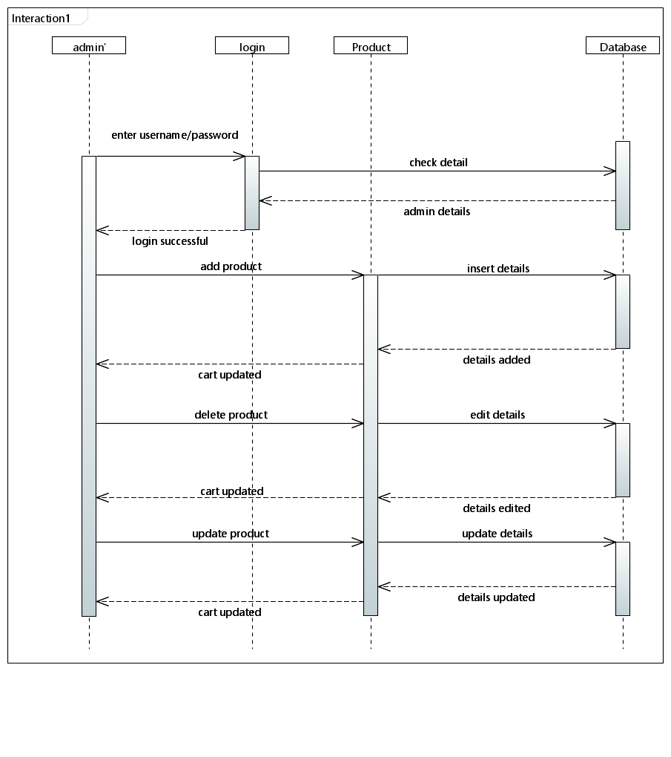

#### Use case Diagram

#### C:\Users\ABC\Desktop\usecase.png

#### StateDiagram

#### Product shopping:

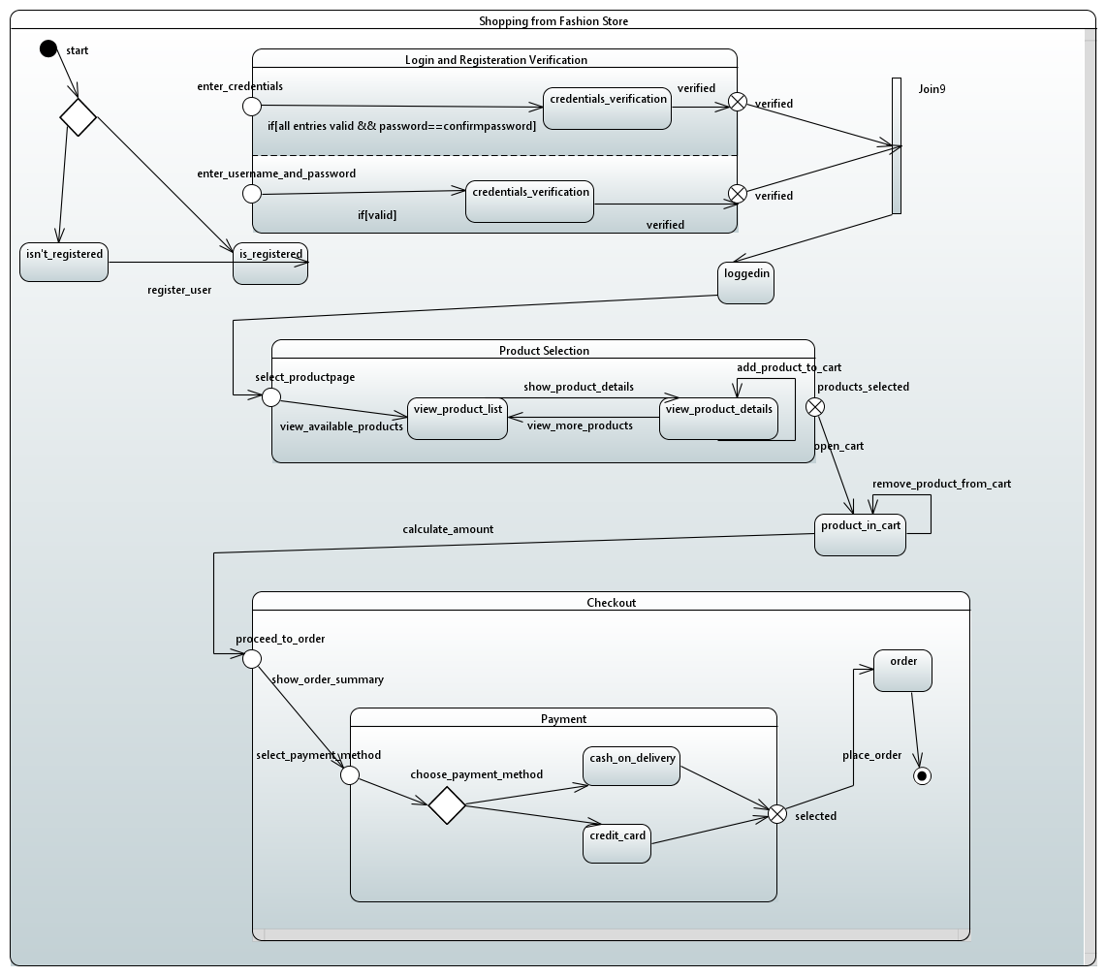

*.*

*.*

.

Product management:

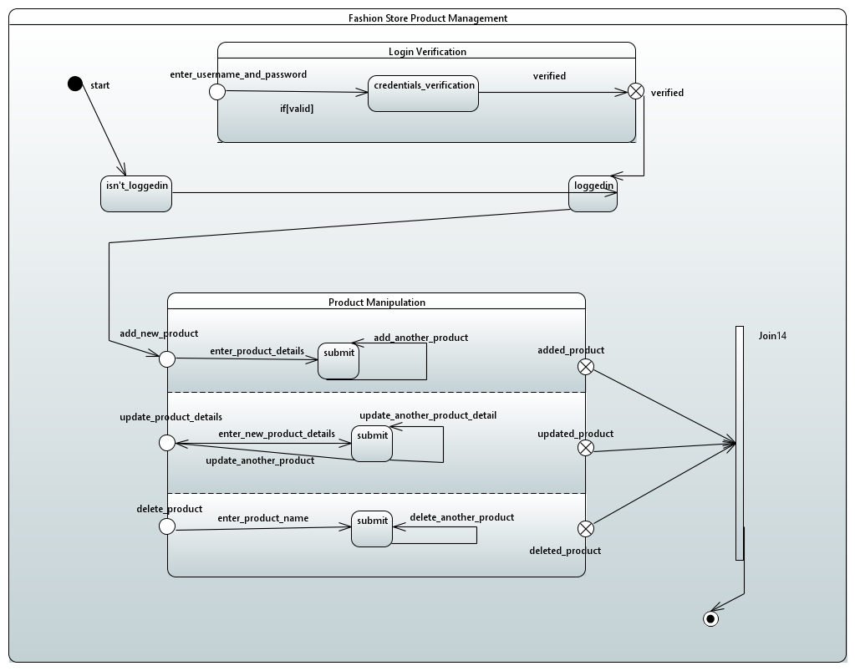

#### ActivityDiagram

**Product shopping:**

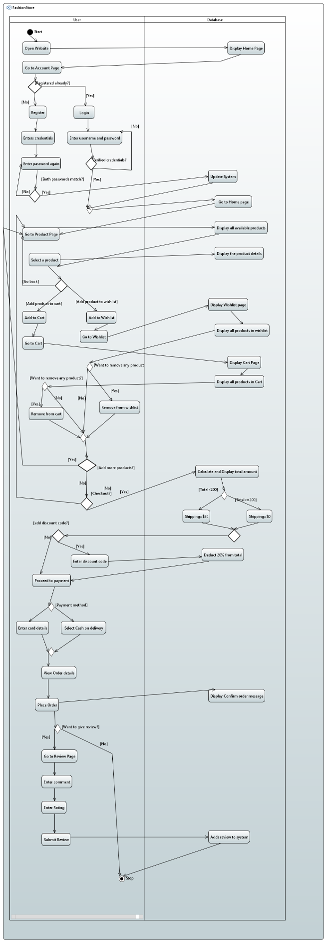

**Product management:**

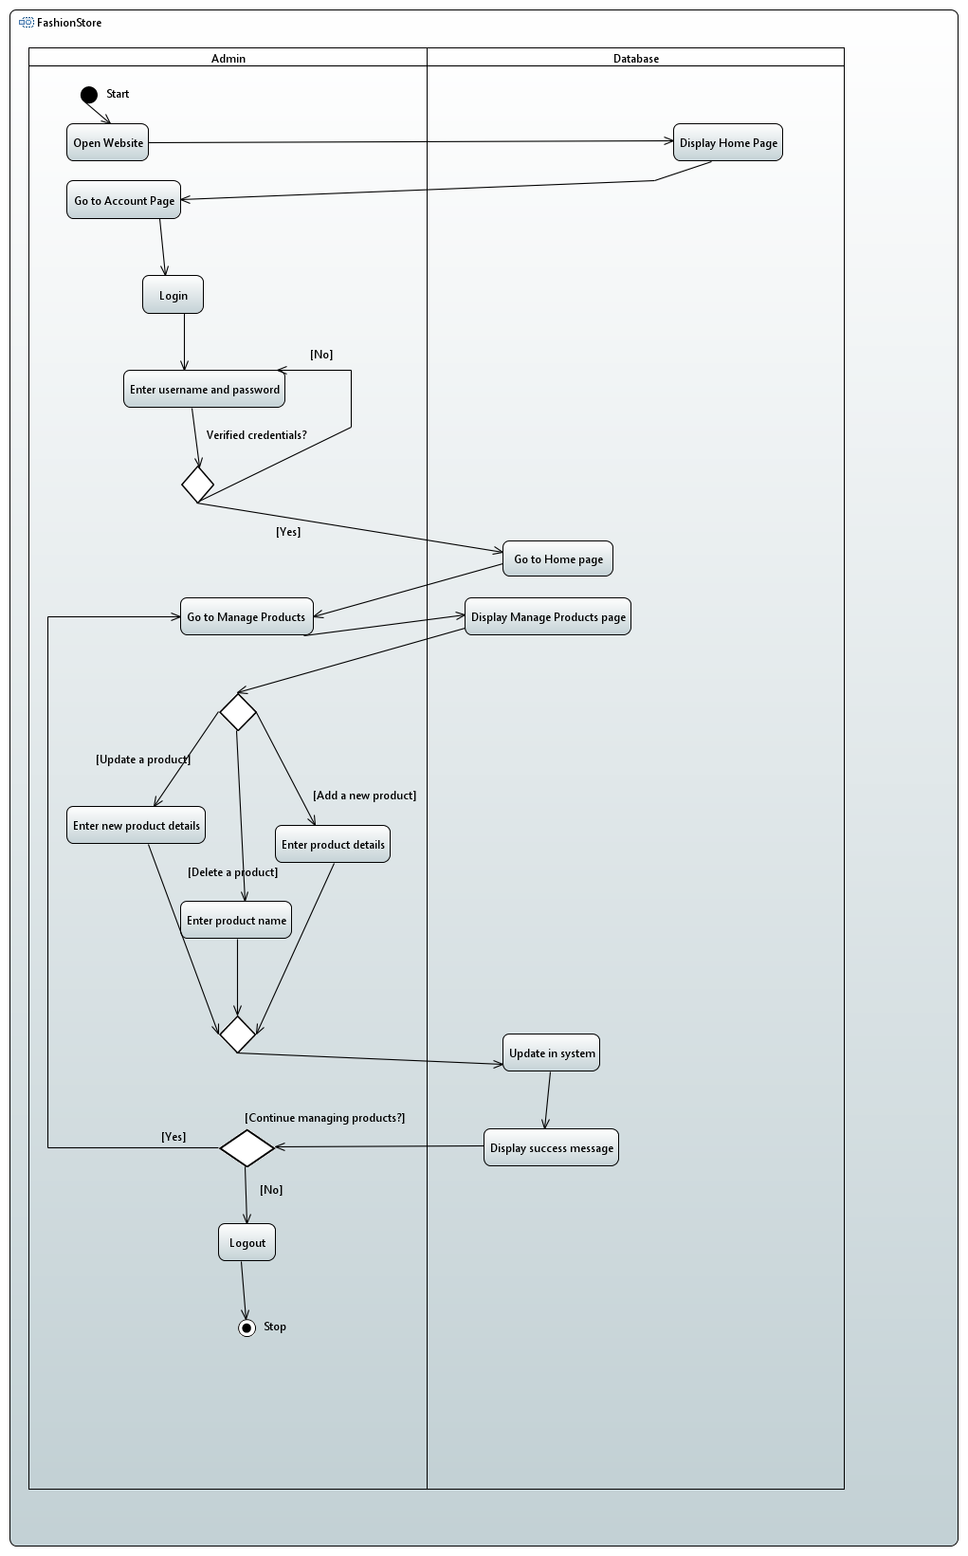

**Component diagram:**

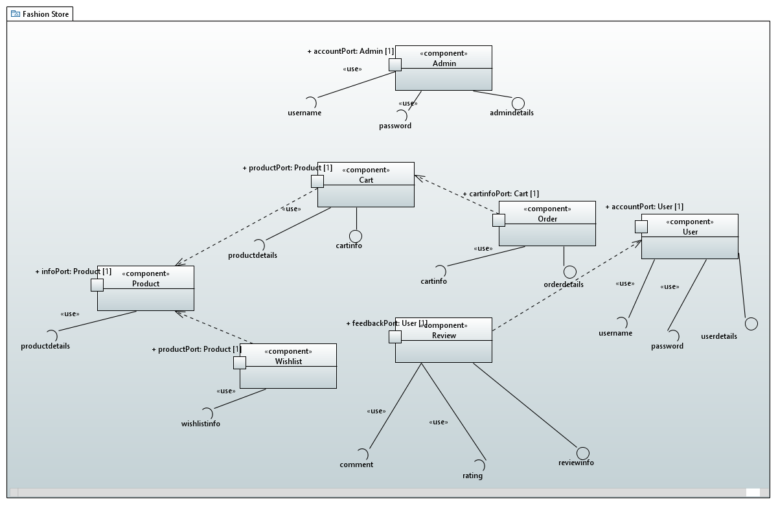

**Deployment diagram:**

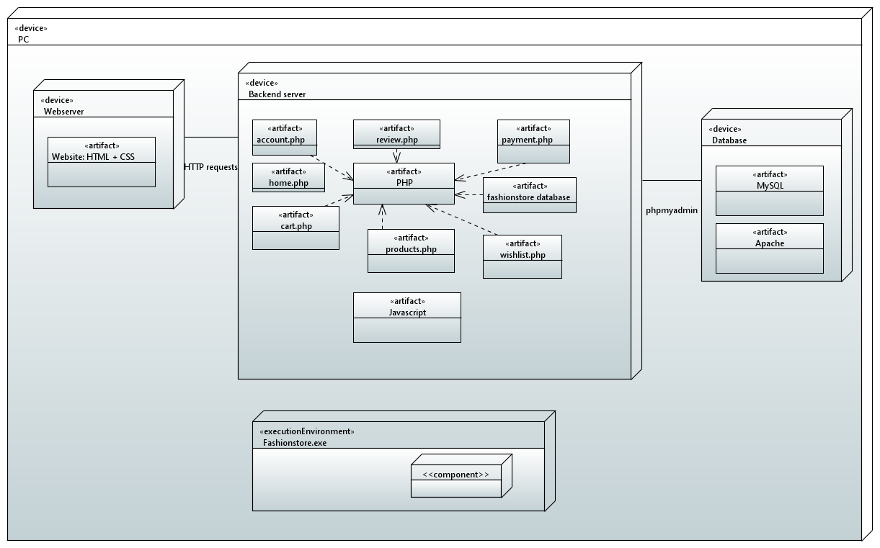

## References

## https://creately.com/blog/diagrams/deployment-diagram-tutorial/

## https://creately.com/blog/diagrams/component-diagram-tutorial/